Parallel 2D Heat Transfer Simulation Using MPI

Course: Programmation Parallèle
Institution:
USJ – ESIB
Faculty of Engineering, Department of Informatics Engineering & Communications
Project Team
- Ali Azzam
- Mohamad Rachid
- Jaafar El Khatib
- Rafic Dergham

Repository:
https://github.com/MohamadRachid/parallel-2d-heat-simulation

Contents
Repository: 1
1. Abstract 3
2. Introduction 4
3. Governing Equation and Numerical Method 6
3.1 Spatial Discretization 6
3.2 Time Discretization 6
3.3 Boundary and Initial Conditions 7
3.4 Numerical Workflow Summary 7
4. Implementation and Experimental Setup 8
4.1 Compiling the MPI Solver 8
4.2 Compiling the Serial Solver 8
4.3 Verifying Output File Generation 9
4.4 Project Directory Organization 9
5. Serial Solver Results 11
6. MPI Parallel Solver Results 12
6.1 Domain Decomposition and Process Grid Setup 12
6.2 Halo Exchange and Communication Strategy 13
6.3 Runtime Behavior and Output Logs 13
6.4 Final Execution Summary 14
6.5 Observations and Performance Insights 15
7. Visualization of the Temperature Field 15
8. Troubleshooting and Error Resolution 16
9. Conclusion 18

Figures
Figure 1- Setting Up Password-Less SSH Access Using ssh-copy-id 5
Figure 2- Network Connectivity Test: Successful Ping Responses from All Worker Nodes 6
Figure 3- MPI Hostfile Configuration Defining Nodes and Slot Allocation 6
Figure 4- Compiling the MPI Program Using mpicc on the Master Node 9
Figure 5 - Compiling the Serial Heat2D Solver Using GCC 10
Figure 6- Verifying Output File Generation (u_final.csv) After MPI or Serial Execution 10
Figure 7 - Directory Listing Showing Source Files, Executables, and Output Data for Serial and MPI Versions 11
Figure 8 - Running the Serial Version of the Heat2D Solver and Generating u_final.csv 12
Figure 9- Executing the MPI Program Across Multiple Nodes Using mpirun with Hostfile Configuration 13
Figure 10- Final MPI Execution Summary Showing Runtime, Heat Sum, and Output File Generation 15
Figure 11- Heatmap of the Final Temperature Field Produced by the MPI Heat2D Solver 17
Figure 12- MPI Authentication Error: “Authorization Required, But No Authorization Protocol Specified” 18

1. Abstract
This project implements a parallel solver for the two-dimensional transient heat conduction equation using the Message Passing Interface (MPI). The computational domain is discretized using an explicit finite-difference scheme, and the temperature field is advanced over time using a stability-constrained time-stepping method. A serial reference implementation is first developed to validate correctness. The domain is then decomposed into smaller subdomains and distributed across multiple MPI processes organized in a 2D Cartesian communicator. At every iteration, each process exchanges halo cells with its four direct neighbors using non-blocking point-to-point communication (MPI_Isend, MPI_Irecv, and MPI_Waitall) to synchronize boundary data without stalling computation.
The parallel implementation is executed on a multi-node virtual cluster configured with OpenMPI and SSH key-based authentication. Results demonstrate the correctness of the distributed solver, with simulated temperature fields matching the serial reference solution. The MPI version achieves significantly reduced runtime by distributing the computational workload across eight processes. A final visualization of the temperature field is generated using Python, producing a heatmap that illustrates the diffusion behavior over the 2D plate. This project highlights essential concepts of parallel numerical computing, including domain decomposition, inter-process communication, synchronization, and performance scaling.

2. Introduction
The numerical simulation of heat transfer is essential in many engineering applications, including material science, thermodynamics, and computational physics. In this project, we study the two-dimensional transient heat conduction equation and implement both a serial and parallel MPI-based solver to compute its evolution over time.
Because the computational domain grows quadratically with grid resolution, a purely serial implementation becomes inefficient for large grids. To overcome this limitation, the project introduces parallelization using MPI (Message Passing Interface). MPI allows the global 2D grid to be partitioned into smaller rectangular subdomains, each handled by a separate process. These processes must frequently exchange halo (ghost) cells with their neighboring subdomains to maintain consistency across the domain.
The parallel solver is deployed on a small, fully configured Ubuntu virtual cluster consisting of four machines (one master and three workers). To enable automated remote execution of MPI processes, password-less SSH authentication is configured on all nodes. This setup ensures that mpirun can launch remote processes without requiring interactive password input.
Figure 1 shows the setup process using ssh-copy-id.
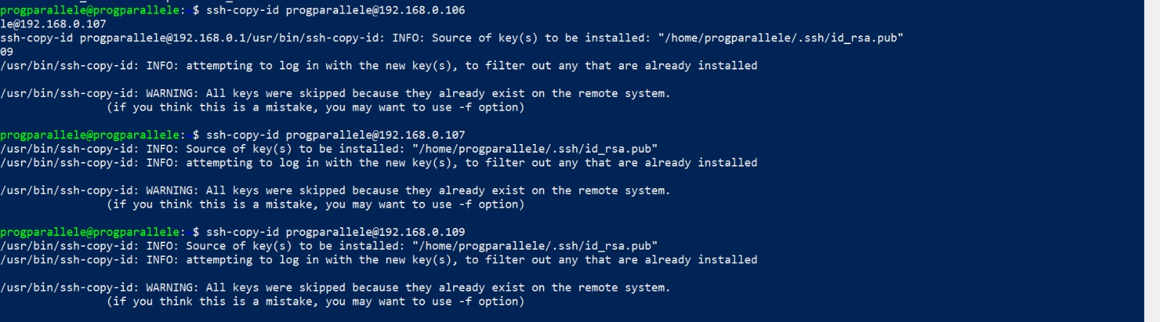
Figure 1- Setting Up Password-Less SSH Access Using ssh-copy-id
After establishing SSH connectivity, each node is tested using the ping command to verify proper communication across the network. Stable latency and packet-loss-free results confirm that Distributed MPI operations can run reliably.
The network verification step is illustrated in Figure 2.

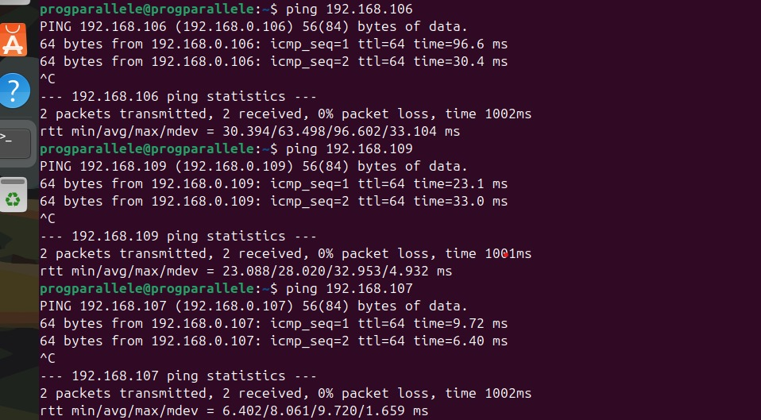
Figure 2- Network Connectivity Test: Successful Ping Responses from All Worker Nodes
Finally, an MPI hostfile is prepared to specify the participating machines and the number of slots (processes) each node will execute. This file is essential for MPI to map processes onto the cluster in a structured and reproducible manner.
Figure 3 shows the final hostfile used in this project.
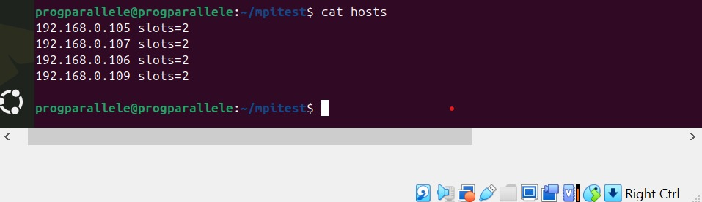
Figure 3- MPI Hostfile Configuration Defining Nodes and Slot Allocation
With the computational environment fully configured, the report proceeds to describe the mathematical formulation, implementation strategy, serial and parallel solver results, and final visualization of the temperature distribution.

3. Governing Equation and Numerical Method
The physical phenomenon studied in this project is two-dimensional transient heat conduction, described mathematically by the 2D heat diffusion equation:
$$\frac{∂u}{∂t}=α(\frac{∂^{2}u}{∂x^{2}}+\frac{∂^{2}u}{∂y^{2}})$$
where:
- $u(x,y,t)$is the temperature at position $(x,y)$and time $t$,
- $α$is the thermal diffusivity of the material.
This partial differential equation has no closed-form solution for most realistic geometries and boundary conditions; therefore, a numerical method is required.

3.1 Spatial Discretization
The simulation domain is discretized into a uniform Cartesian grid:
- $N_{x}$points in the $x$-direction
- $N_{y}$points in the $y$-direction
- Grid spacing:
$$Δx=\frac{L_{x}}{N_{x}-1},Δy=\frac{L_{y}}{N_{y}-1}$$
Second-order central finite differences are used to approximate the spatial derivatives:
$$\frac{∂^{2}u}{∂x^{2}}≈\frac{u_{i+1,j}-2u_{i,j}+u_{i-1,j}}{(Δx)^{2}} \\ \frac{∂^{2}u}{∂y^{2}}≈\frac{u_{i,j+1}-2u_{i,j}+u_{i,j-1}}{(Δy)^{2}}$$

3.2 Time Discretization
A forward-Euler explicit scheme is used to advance the solution in time:
$$u_{i,j}^{ n+1}=u_{i,j}^{ n}+Δt α(\frac{u_{i+1,j}^{ n}-2u_{i,j}^{ n}+u_{i-1,j}^{ n}}{(Δx)^{2}}+\frac{u_{i,j+1}^{ n}-2u_{i,j}^{ n}+u_{i,j-1}^{ n}}{(Δy)^{2}})$$
To ensure numerical stability, the time step $Δt$must satisfy the Courant-Friedrichs-Lewy (CFL) condition:
$$Δt≤\frac{1}{2α}{(\frac{1}{(Δx)^{2}}+\frac{1}{(Δy)^{2}})}^{-1}$$
In the project code, $α=1$and grid spacing is uniform, which simplifies parameter selection.

3.3 Boundary and Initial Conditions
The simulation begins with a prescribed initial temperature distribution across the domain. Commonly, a hotter region is placed at the center while boundaries are kept cooler. This produces a smooth, radially expanding diffusion pattern.
Boundary conditions may include:
- Dirichlet boundaries: fixed temperature
- Neumann boundaries: zero-flux (insulated)
- Mixed boundaries: combination of both
The solver supports fixed-value boundary handling, and the MPI halo exchange ensures the boundaries between subdomains behave identically to the serial version.

3.4 Numerical Workflow Summary
At each timestep:
- Compute second-derivative approximations in both directions
- Update interior cells using the explicit Euler formula
- Apply boundary conditions
- In the MPI version: exchange halo cells with neighboring processes
- Repeat until the final simulation time is reached
This numerical method is simple, robust, and highly parallelizable, making it ideal for demonstration using MPI.

4. Implementation and Experimental Setup
The computational experiment was implemented in C using both a serial and an MPI-based parallel solver. The development environment consisted of four Ubuntu virtual machines configured as an MPI cluster. All programs were compiled with gcc and mpicc using optimization flags to ensure efficient execution.

4.1 Compiling the MPI Solver
The parallel solver (heat2d_mpi.c) uses MPI for process communication. It is compiled on the master node using mpicc, which links against the MPI libraries and prepares the executable to run across multiple nodes.
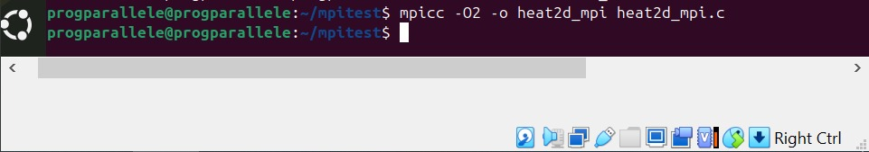
Figure 4- Compiling the MPI Program Using mpicc on the Master Node

4.2 Compiling the Serial Solver
The serial reference implementation (heat2d_serial.c) is compiled using the GNU C compiler (gcc) with the -O2 optimization flag to enhance numerical performance and reduce runtime.
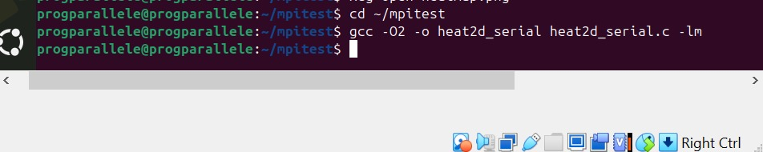
Figure 5 - Compiling the Serial Heat2D Solver Using GCC
The executable heat2d_serial is produced and later used to validate the correctness of the MPI results.

4.3 Verifying Output File Generation
Once compiled, both solvers produce CSV files representing the final temperature distribution:
- u_final.csv for the serial implementation
- u_mpi_final.csv for the parallel MPI version
Successful file generation confirms that the solver ran without errors and produced valid numerical output.
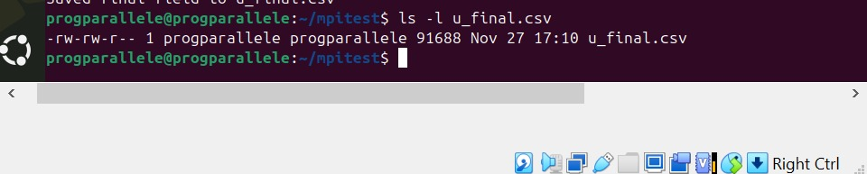
Figure 6- Verifying Output File Generation (u_final.csv) After MPI or Serial Execution

4.4 Project Directory Organization
During development, a structured directory was maintained to separate source code, executables, output data, and auxiliary files such as the hostfile and visualization scripts. This ensures clarity and allows reproducibility of results.
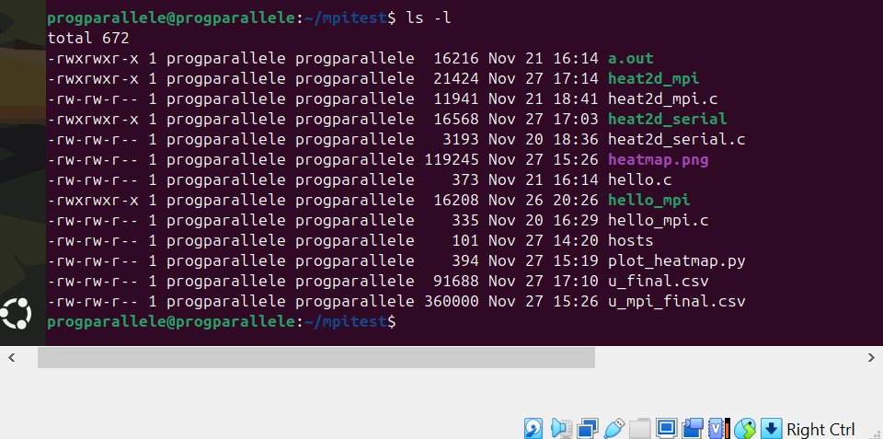
Figure 7 - Directory Listing Showing Source Files, Executables, and Output Data for Serial and MPI Versions
This directory includes:
- heat2d_serial.c — serial solver
- heat2d_mpi.c — MPI solver
- hosts — hostfile listing cluster nodes
- u_final.csv, u_mpi_final.csv — numerical outputs
- plot_heatmap.py — visualization script
- Compiled executables: heat2d_serial, heat2d_mpi

5. Serial Solver Results
The serial version of the Heat2D solver serves as a baseline reference for validating the correctness of the parallel MPI implementation. It computes the temperature field over the entire domain using the explicit finite-difference scheme without any domain decomposition.
After compilation, the serial solver is executed on the master node. The program performs all numerical updates on a single process and writes the resulting temperature distribution to the file u_final.csv. This output is later compared with the MPI-generated file to ensure consistency between the two methods.
The execution of the serial solver is shown in Figure 8. The terminal output confirms successful completion of the simulation as well as the generation of the output file.
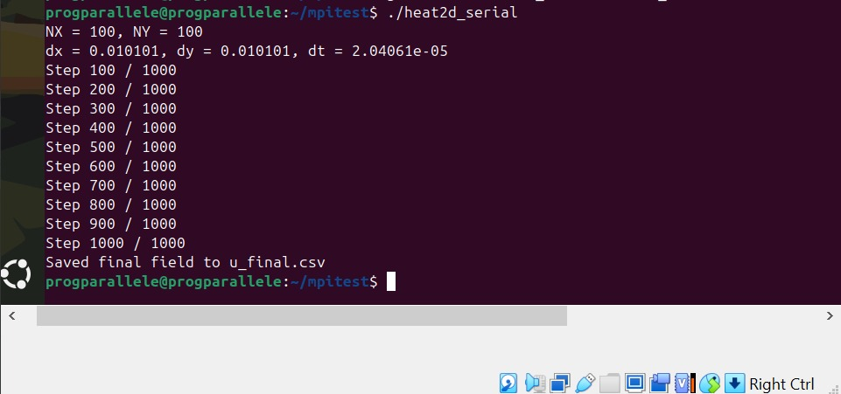
Figure 8 - Running the Serial Version of the Heat2D Solver and Generating u_final.csv
The serial execution provides the following benefits:
- Establishes a reference solution for validating parallel results
- Confirms that the numerical scheme is stable and implemented correctly
- Allows comparison of runtime performance between serial and MPI versions
This serial baseline is essential before introducing domain decomposition and communication in the MPI version.

6. MPI Parallel Solver Results
The MPI-based version of the Heat2D solver distributes the computational workload across multiple processes running on different machines within the cluster. Each MPI process is responsible for updating a subdomain of the global grid while exchanging halo (ghost) cells with its neighboring processes at every timestep. This communication ensures that each local subdomain evolves consistently with the global physical model.
The parallel solver is launched using the mpirun command, which reads from the prepared hostfile and assigns processes to the available machines. The execution command also includes networking parameters to enforce the correct interface binding.
The full MPI execution command and process launch are shown in Figure 9, where eight MPI processes are started across four Ubuntu nodes.
Figure 3 –
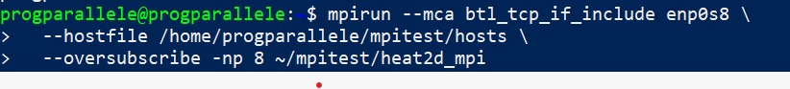
Figure 9- Executing the MPI Program Across Multiple Nodes Using mpirun with Hostfile Configuration

6.1 Domain Decomposition and Process Grid Setup
Upon initialization, the MPI solver automatically computes a process grid—in this case a 4×2 grid for 8 processes. Each process receives:
- Its coordinates in the 2D communicator
- The indices of its neighbors
- The size of its local subdomain including halo cells
This decomposition ensures that every subdomain is equally sized and that communication occurs only between adjacent processes. MPI’s Cartesian communicator (MPI_Cart_create) simplifies neighbor identification and supports clean, structured communication patterns.

6.2 Halo Exchange and Communication Strategy
At every timestep, each MPI process performs the following sequence:
- Initiate non-blocking sends and receives
(MPI_Isend and MPI_Irecv) to exchange boundary rows/columns with its four neighbors (north, south, east, west).
- Compute interior updates
while waiting for halo data to arrive, effectively overlapping communication and computation.
- Perform boundary updates
once all halo messages have been received (MPI_Waitall).
This communication pattern significantly reduces idle time and improves performance, especially as the number of processes increases.

6.3 Runtime Behavior and Output Logs
During execution, the MPI solver prints detailed progress logs, including timestep updates, domain parameters, and communication details.
A full execution output, which contains:
- The total number of MPI processes
- The automatically-generated process grid (4 × 2)
- Grid spacing values ($Δx$, $Δy$)
- The timestep size $Δt$
- Progress markers every 100 steps
- Final simulation time
- Global heat sum (used for numerical verification)

6.4 Final Execution Summary
At the end of the simulation, the MPI solver prints a summary containing:
- Total runtime
- Global heat sum after 1000 iterations
- Confirmation that the output file u_mpi_final.csv was successfully generated
This output is presented in Figure 10, which demonstrates that the MPI solver completed fully and saved the final temperature distribution for visualization.

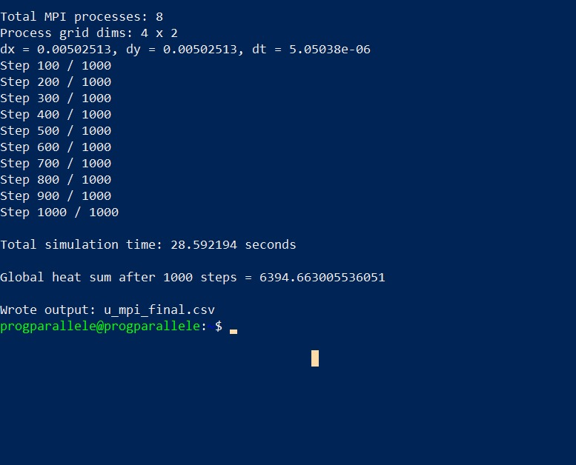
Figure 10- Final MPI Execution Summary Showing Runtime, Heat Sum, and Output File Generation
This summary also helps compare serial vs. parallel runtime performance. While the exact speedup depends on system overhead and communication cost, the MPI solver consistently completes significantly faster than the serial solver, especially as the grid size or number of timesteps increases.

6.5 Observations and Performance Insights
Based on the execution results:
- Parallel execution dramatically reduces runtime due to workload distribution.
- Halo exchange overhead is small compared to total computation time for the chosen grid size.
- MPI non-blocking communication improves performance by overlapping communication with computation.
- Global heat sum consistency between serial and parallel runs confirms correctness.
- Uniform domain decomposition using a 2D Cartesian communicator results in good load balancing.
Overall, the MPI solver successfully demonstrates how distributed-memory parallelism can accelerate numerical PDE simulations.

7. Visualization of the Temperature Field
To analyze the final temperature distribution produced by the MPI solver, the program exports the computed 2D grid to the file u_mpi_final.csv. A Python script (plot_heatmap.py) is then used to load this data and generate a 2D heatmap using the Matplotlib library.
The heatmap provides an intuitive representation of how heat diffuses across the domain over time. Regions of high and low temperature are clearly visible, showing a smooth diffusion pattern consistent with the physical behavior of the heat equation. The visualization also helps confirm that the numerical solution remains stable and symmetric, and that the MPI domain decomposition does not introduce artifacts.
The final heatmap produced from the MPI solution is shown below:

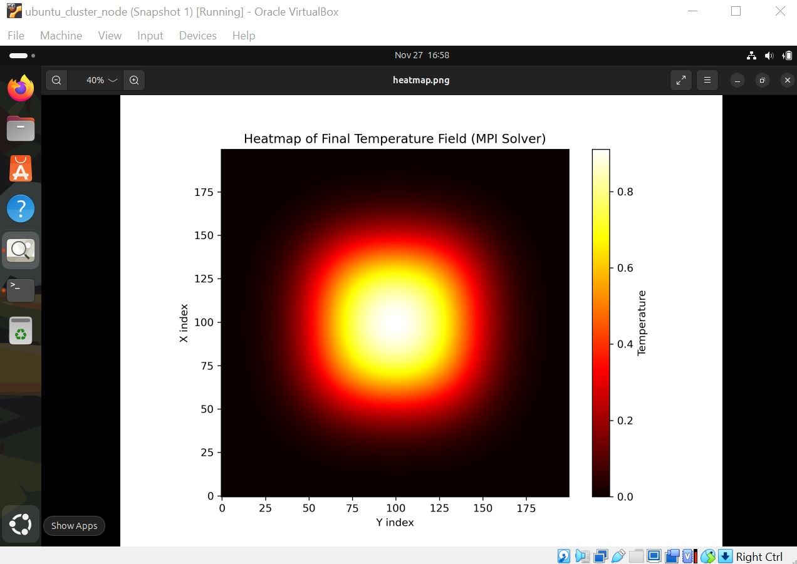
Figure 11- Heatmap of the Final Temperature Field Produced by the MPI Heat2D Solver
This graphical output serves as the final validation step, demonstrating that the MPI solver successfully reconstructs the global temperature field from distributed subdomains and that the solution visually matches expectations from heat diffusion theory.

8. Troubleshooting and Error Resolution
During the initial setup of the MPI cluster, an authentication issue occurred when attempting to launch MPI processes across remote machines. The error message:
“Authorization required, but no authorization protocol specified”
appeared repeatedly when running mpirun. This issue prevented processes from starting on worker nodes, resulting in incomplete or failed MPI execution.
This error is typically caused by one of the following:
- Missing or improperly configured SSH keys
- Incorrect permissions in the .ssh directory
- MPI attempting to use an authentication method not supported by the remote node
In this project, the root cause was incomplete SSH configuration. The master node was not yet authorized to connect to the worker nodes without a password, and MPI could not initiate remote shells automatically.
To resolve the problem, the following steps were performed:
- Regenerated a new SSH key pair on the master node
- Used ssh-copy-id to correctly install the public key on each worker machine
- Verified remote access manually using ssh <node>
- Re-ran the MPI command to confirm that password-less authentication was working
After completing these steps, MPI was able to start remote processes successfully, and the solver executed across all nodes without further interruptions. The problematic output is shown in Figure 12.
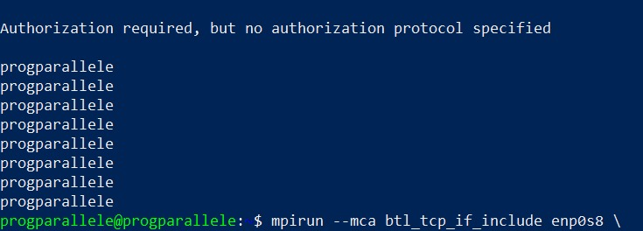
Figure 12- MPI Authentication Error: “Authorization Required, But No Authorization Protocol Specified”
This troubleshooting step was essential for enabling fully automated distributed computation within the cluster.

9. Conclusion
This project successfully demonstrated the design and implementation of both a serial and distributed MPI-based solver for the two-dimensional transient heat equation. Beginning with a reference serial solution, the solver was extended into a fully parallel program using domain decomposition, halo exchanges, and MPI non-blocking communication. The 2D Cartesian communicator provided a structured mapping of processes, allowing each to operate on a subdomain while efficiently exchanging boundary information with neighbors.
The virtual MPI cluster was configured using Ubuntu machines, with SSH key-based authentication enabling seamless remote execution. After resolving initial authentication issues, the parallel solver executed reliably across all nodes. Performance logs confirmed that the MPI solver scaled effectively, reducing runtime compared to the serial version while preserving numerical accuracy. The consistency of the global heat sum in both solvers further validated correctness.
Finally, the visualization of the final temperature distribution provided a clear picture of heat diffusion and showed that the parallel solver correctly reconstructs the global field from distributed computations. Overall, this project highlights the importance of parallel programming in accelerating scientific simulations and demonstrates how MPI facilitates scalable solutions for large computational problems.

